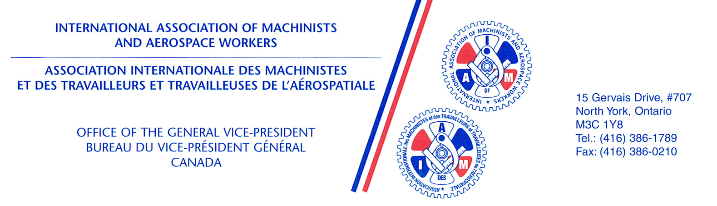
February 19, 2016

The Honourable Judy Sgro
Chair
Standing Committee on Transport, Infrastructure and Communities
House of Commons
Ottawa, Ontario K1A 0A6

Dear Ms. Sgro,

I am writing you on behalf of the International Association of Machinists and Aerospace Workers. We are the largest union at Air Canada, representing Air Canada’s maintenance workforce. We also represented the workers at the now-defunct AVEOS, Air Canada’s spun-off heavy maintenance division.

We are greatly concerned by reports that the Minister of Transport is planning to amend the Air Canada Public Participation Act to remove Air Canada’s statutory obligation to perform its heavy maintenance work at facilities in Montreal, Winnipeg and Mississauga.

Such an amendment would allow Air Canada to circumvent the recent decision of the Quebec Court of Appeal that would require Air Canada to rebuild its heavy maintenance capacity in Canada, based on little more than its vague promise to have some of its future work performed in Canada, when and if it proceeds with its announced order of Bombardier C-Series aircraft.

This is particularly troubling because the Quebec and Manitoba governments were forced to litigate this matter when the former federal government refused to enforce its own legislation and require Air Canada to comply.

We urge you to ensure that, should the Minister bring forward legislation to amend the ACPPA, the Standing Committee will hold public hearings on the proposed legislation, and allow the IAMAW to appear before the Committee, to explain our concerns and make recommendations on how this sector and its many thousands of high-quality jobs can, and should, be supported in the future.

If you wish to discuss this matter further, we are available to meet with you at your convenience.
Sincerely,
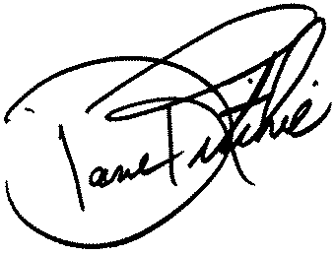
Dave Ritchie
General Vice President

cc: Members of the Standing Committee
Minister Garneau
Fred Hospes
Hassan Yussuff

